Permalink: word-documents

**Word documents**

[Blot](https://blot.im) can now convert *.docx* files into blog posts automatically! I like this feature because adding images to blog posts couldn’t be easier: just drag and drop them into Word and Blot handles the rest.

Please note that **many formatting features are ignored** or unsupported. This is mostly a good thing, and helps you keep your blog visually consistent. Blot will preserve **bold**, *italic* and ~~struck-out~~ text, images, [links](https://blot.im/), lists, and tables.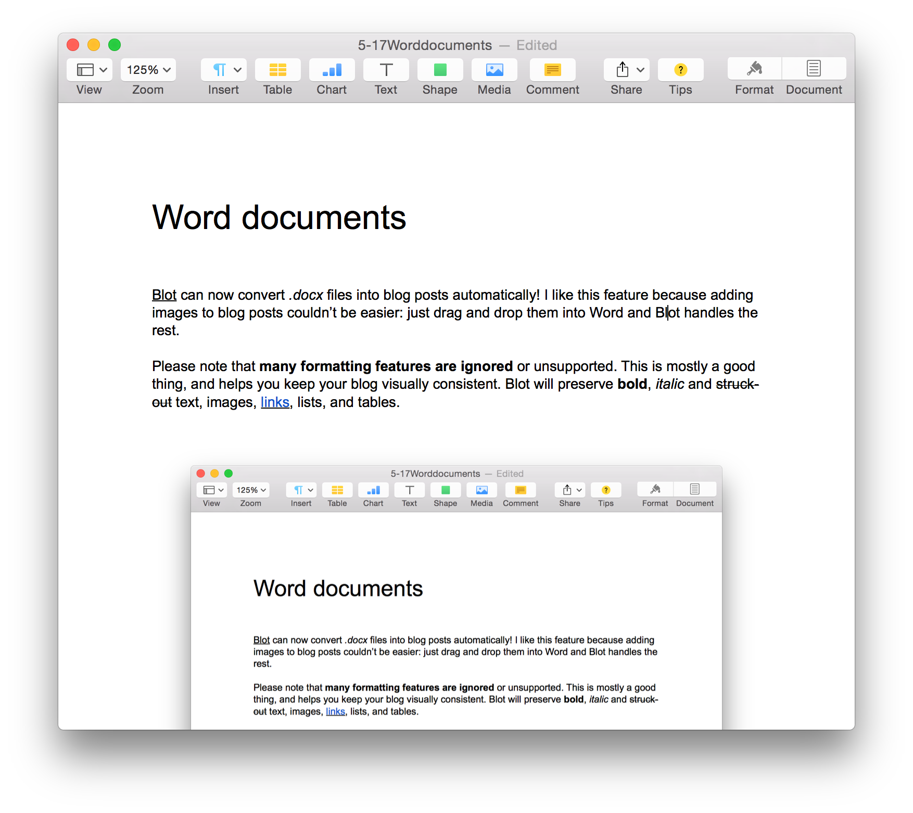

Word documents are a complicated proprietary format and converting them to HTML is challenging. Please [let me know](https://blot.im/contact) if you encounter any especially worrying bugs.